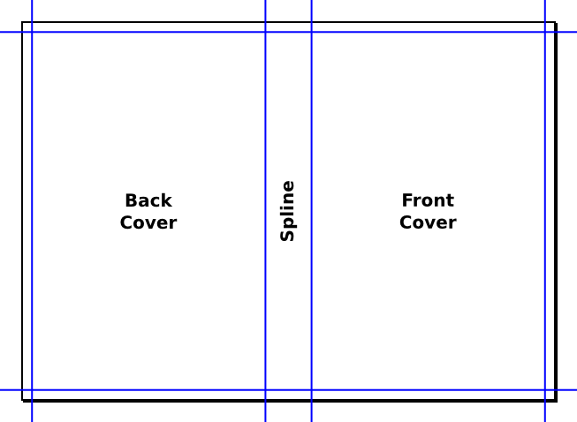

Title: What will you name your book? How would you describe your life in just a few line.

Example:

Exploits of a Super Skateboarder!

or

**For the Love of Plants.**

One teacher’s experience told from the point of view of the plants in her classroom.

By: Your name

Example: **Ann Ogle**

Summary: What would you like people to know about you? What would you like to highlight about your life – great events, experiences, your talents, etc.

About the author: Tell a brief history of your life. Where you born, family, pets, ect.

Example:

For the Love of Plants. One teacher’s experiences told from the point of view of the plants in her classroom. Have you ever wondered what a classroom would look like if you were a fly on the wall? Well, now you can experience a middle school teacher’s experiences and tips told from the point of view of the plants in her room.

“Hillarious!” declared Janet Evanovich

“A must read this summer!” exclaimed JD Robb

Ann Ogle, lives in Kennesaw, Georgia with her husband, three dogs and cat. Both Ann and her husband are avid gardeners, and hikers.

A

Ogle

For the Love of Plants.

